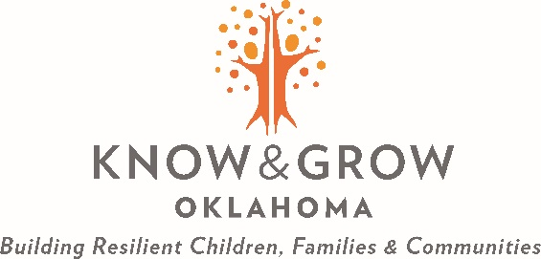

Know and Grow Oklahoma Family Resource Center Workplan

Organization name:

Instructions

The workplan should describe the key process objectives, goals, and outcomes for successful program implementation.

To achieve each of the objectives proposed and the anticipated deliverables:
- The workplan should include a chronological list of activities to be performed for each strategy.
- Each activity should have an identified responsible staff member.
- Objectives, measures, and goals should be S.M.A.R.T (Specific, Measurable, Achievable, Relevant and Time-based)
- The workplan should include a 3-month community assessment planning period if the responding service provider has not conducted a community assessment within the past 12 months.
- The four strategies of the National Family Support Network to address are Service Access and System Navigation, Family Management, Parent Advisory Committee and Community Collaborations. Individual forms are provided for each strategy.
- There should be at least one objective for each identified goal and key activities for each objective identified.
- If you need extra lines in any section, please add them as needed.

Strategy: Service Access and Systems Navigation
Goal:
Measurable Objectives
Objective #1
Activities to meet Objective | Start to Finish Dates | Key staff/Titles | Collaborating Community Partners | Intended Outcomes
1.
2.
3.
Objective #2
Activities to meet Objective | Start to Finish Dates | Key staff/Titles | Collaborating Community Partners | Intended Outcomes
1.
2.
3.

Strategy: Family Management
Goal:
Measurable Objectives
Objective #1
Activities to meet Objective | Start to Finish Dates | Key staff/Titles | Collaborating Community Partners | Intended Outcomes
1.
2.
3.
Objective #2
Activities to meet Objective | Start to Finish Dates | Key staff/Titles | Collaborating Community Partners | Intended Outcomes
1.
2.
3.
Strategy: Parent Advisory Committee
Goal:
Measurable Objectives
Objective #1
Activities to meet Objective | Start to Finish Dates | Key staff/Titles | Collaborating Community Partners | Intended Outcomes
1.
2.
3.
Objective #2
Activities to meet Objective | Start to Finish Dates | Key staff/Titles | Collaborating Community Partners | Intended Outcomes
1.
2.
3.

Strategy: Community Collaboration
Goal:
Measurable Objectives
Objective #1
Activities to meet Objective | Start to Finish Dates | Key staff/Titles | Collaborating Community Partners | Intended Outcomes
1.
2.
3.
Objective #2
Activities to meet Objective | Start to Finish Dates | Key staff/Titles | Collaborating Community Partners | Intended Outcomes
1.
2.
3.

